**At this point in the process, it is decided to not use the 15 watersheds used in the Ahiablame paper and rather pick around 15 different ones, that include significant baseflow but still have USGS flow and good long-term water quality measurements. Map on right at bottom.**

**USGS 03275600 / GMW070-0006 (N, P, and TSS) [1991 to 2010]**

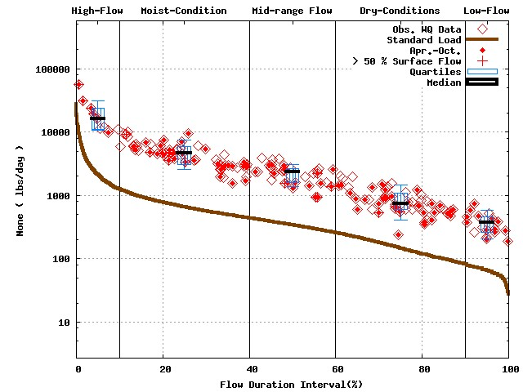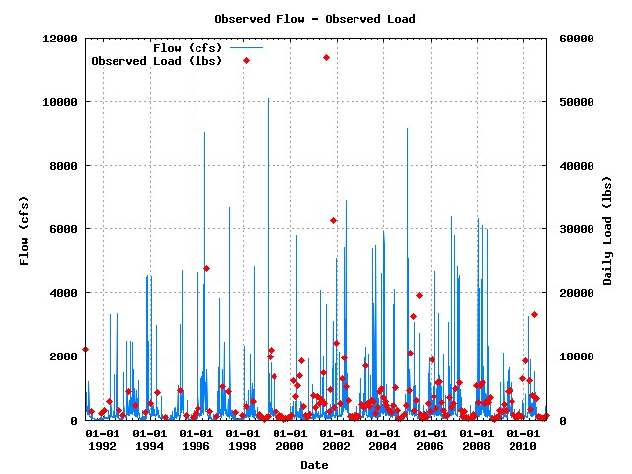

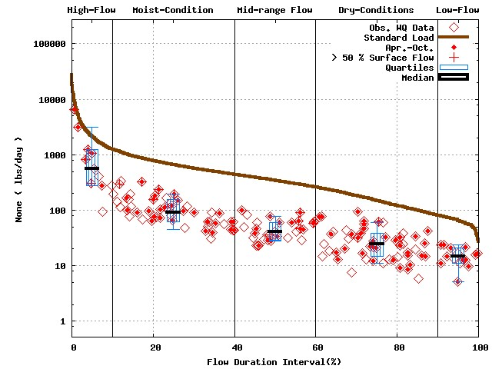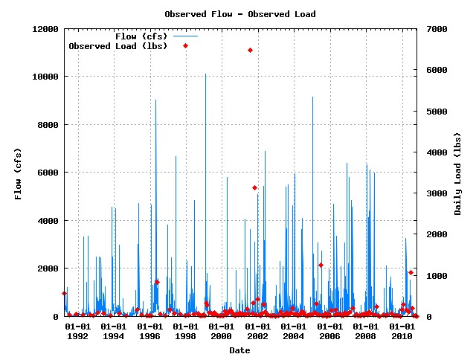

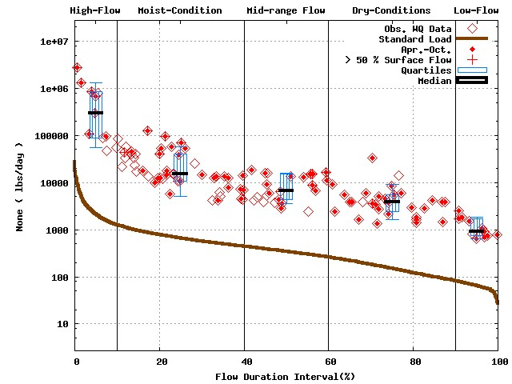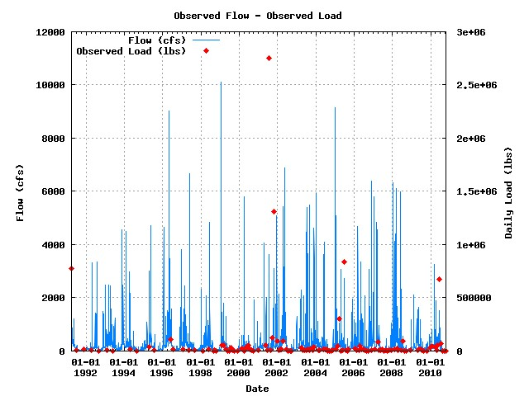

Numbers of water quality sample for Baseflow dominant flow cases 98/90/66

**USGS 03275600 / GMW070-0006 (Baseflow dominant flow’s plot) [1991 to 2010]**



**USGS 03302800 / OBS140-0004 (N, P, and TSS) [1991 to 2010]**

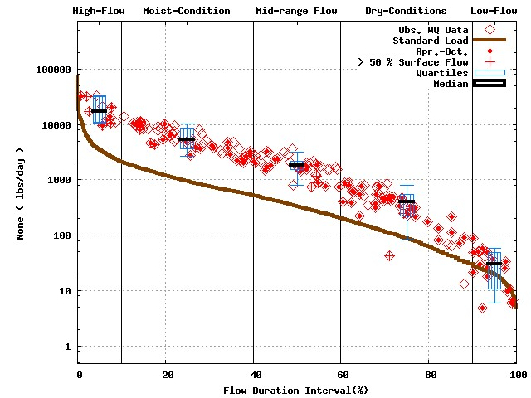 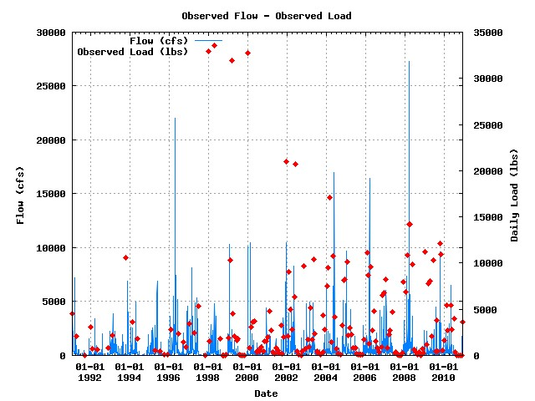

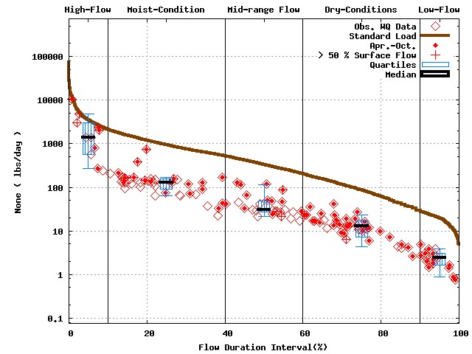 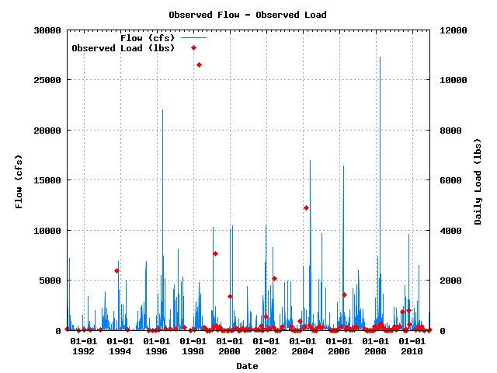

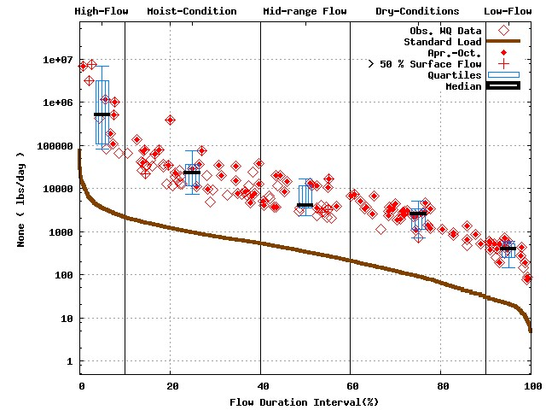 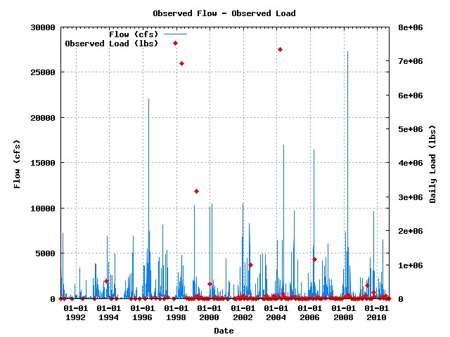

Numbers of water quality sample for Baseflow dominant flow cases 110/82/90

**USGS 03302800 / OBS140-0004 (Baseflow dominant flow’s plot) [1991 to 2010]**



**USGS 03324000 / WUW070-0002 (N, P, and TSS) [1991 to 2010]**

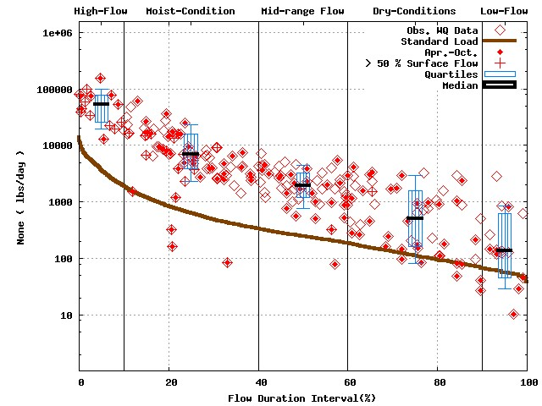 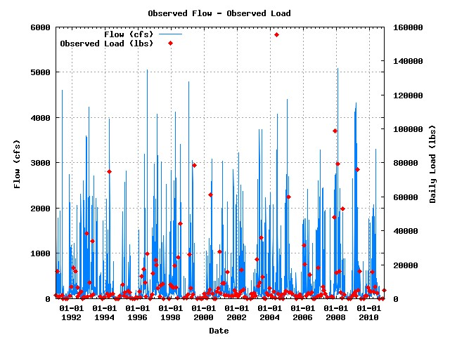

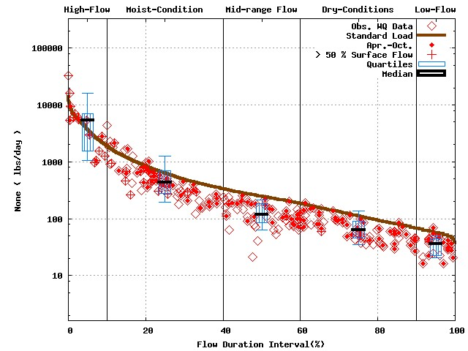 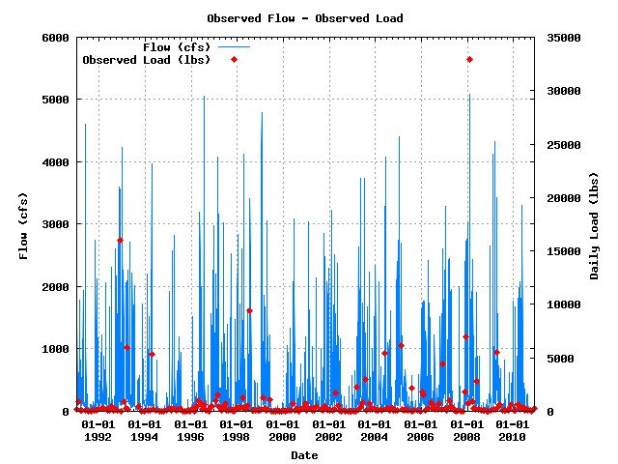

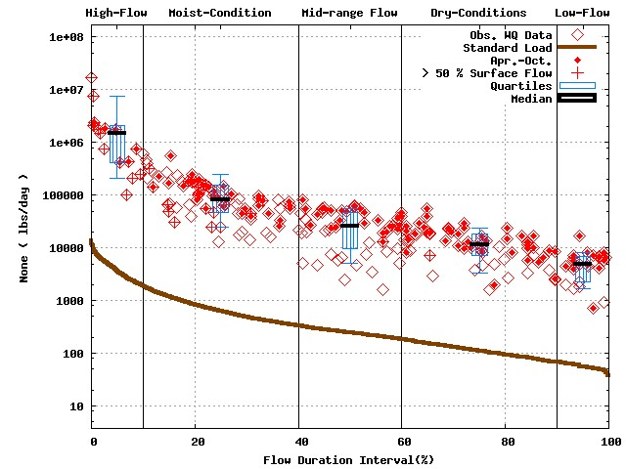 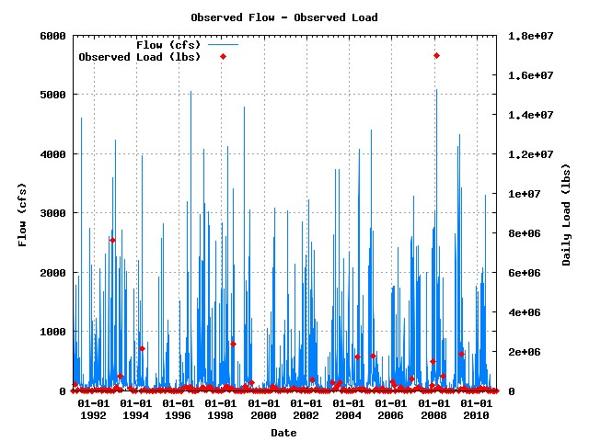

Numbers of water quality sample for Baseflow dominant flow cases 124/134/129

**USGS 03324000 / WUW070-0002 (Baseflow dominant flow’s plot) [1991 to 2010]**



**USGS 03325500 / WMI020-0002 (N, P, and TSS) [1991 to 2010]**

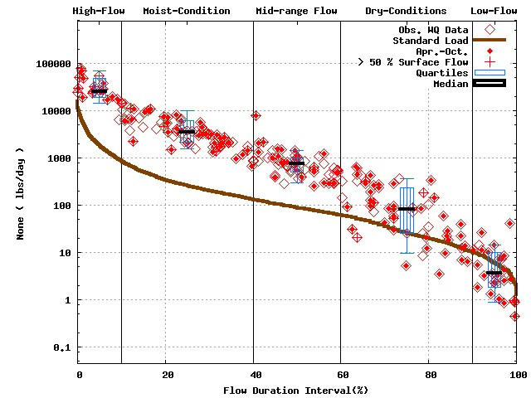 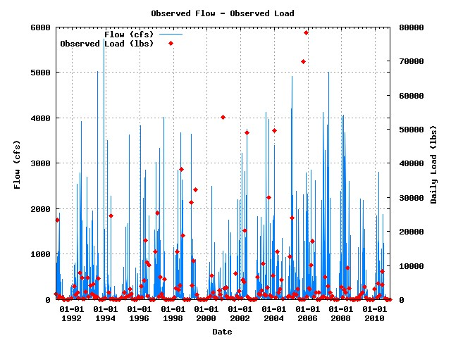

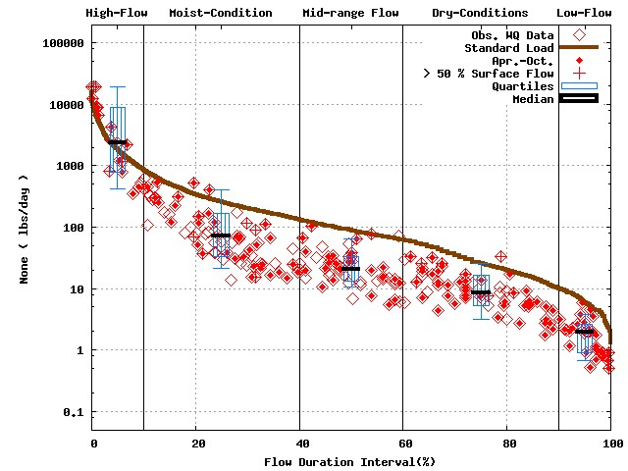 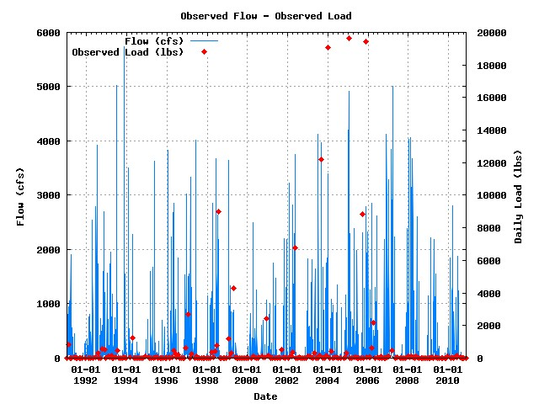

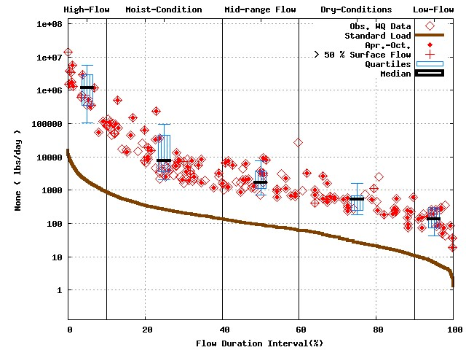 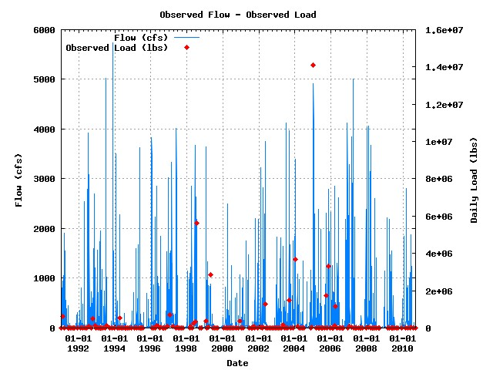

Numbers of water quality sample for Baseflow dominant flow cases 124/123/100

**USGS 03325500 / WMI020-0002 (Baseflow dominant flow’s plot) [1991 to 2010]**



**USGS 03327500 / WUW160-0006 (N, P, and TSS) [1991 to 2010]**

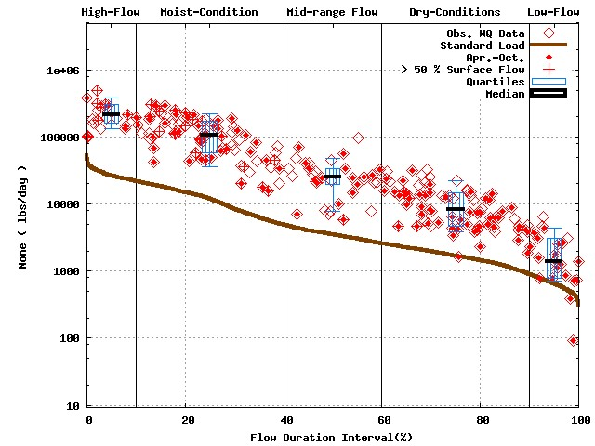 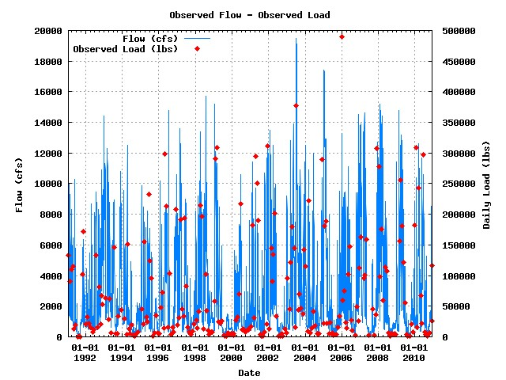

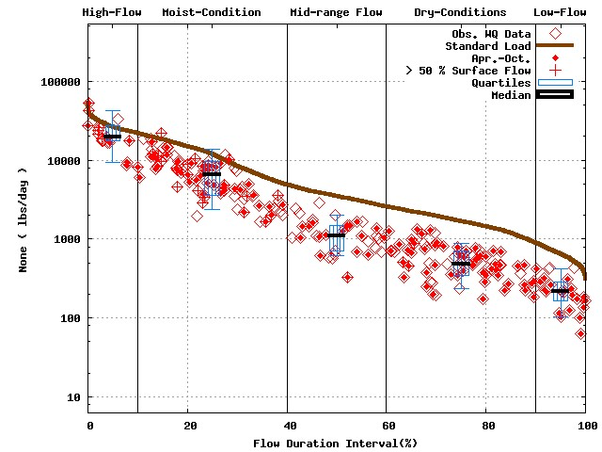 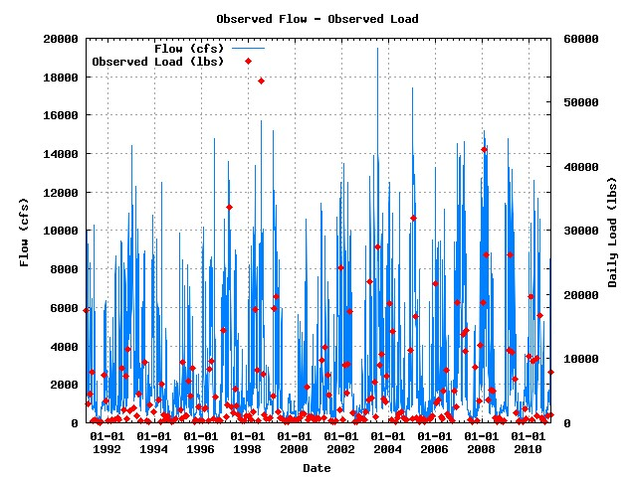

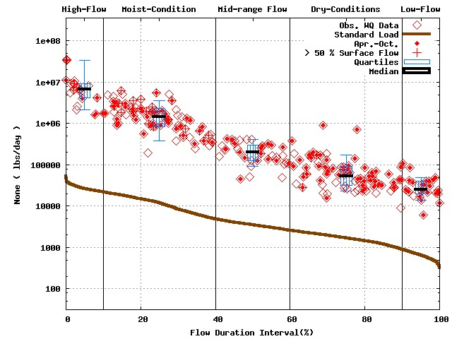 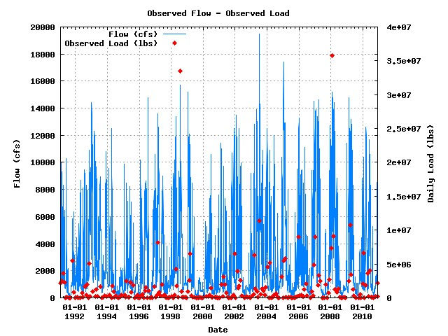

Numbers of water quality sample for Baseflow dominant flow cases 90/91/90

**USGS 03327500 / WUW160-0006 (Baseflow dominant flow’s plot) [1991 to 2010]**



**USGS 03328500 / WAE070-0011 (N, P, and TSS) [1991 to 2010]**

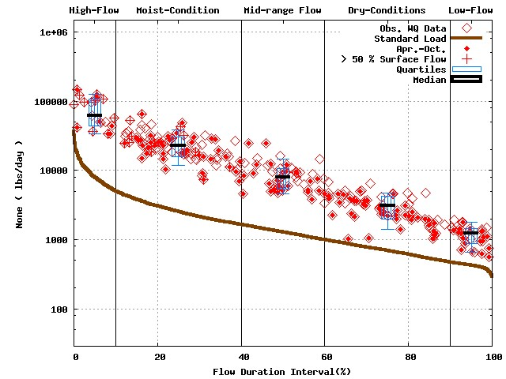 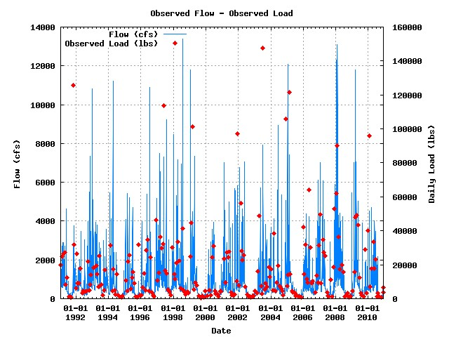

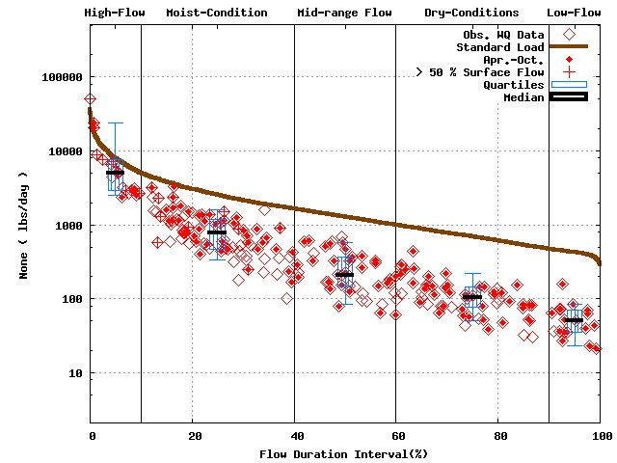 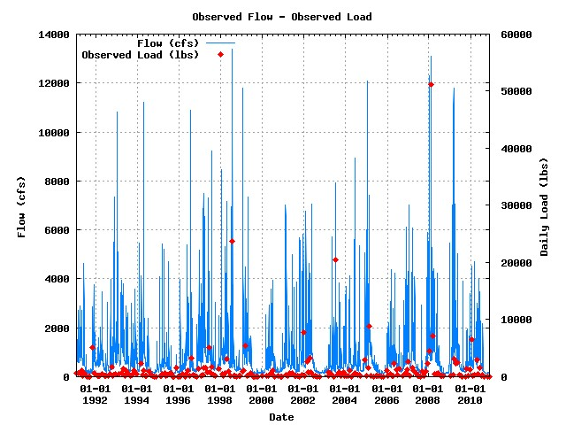

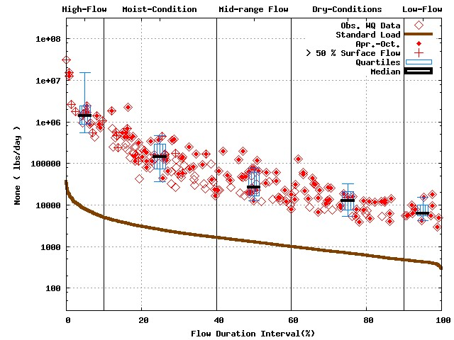 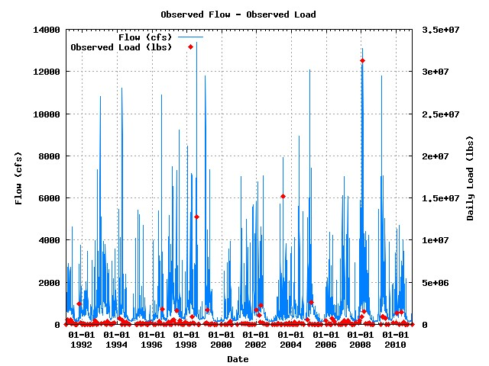

Numbers of water quality sample for Baseflow dominant flow cases 123/120/112

**USGS 03328500 / WAE070-0011 (Baseflow dominant flow’s plot) [1991 to 2010]**



**USGS 03339500 / WSU050-0005 (N, P, and TSS) [1991 to 2010]**

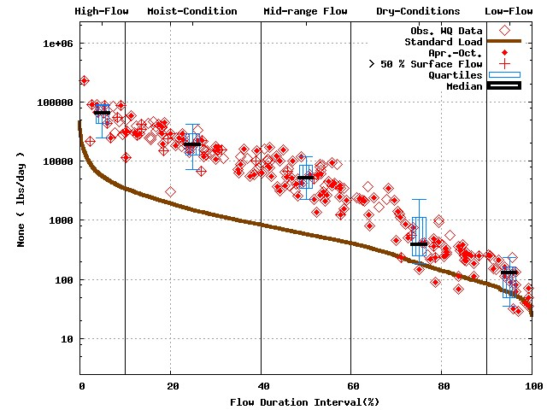 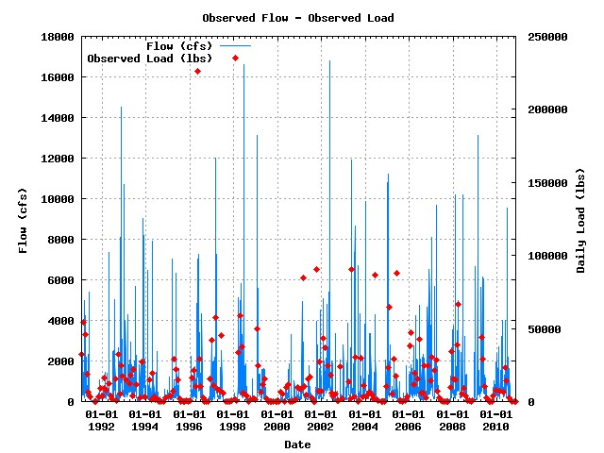

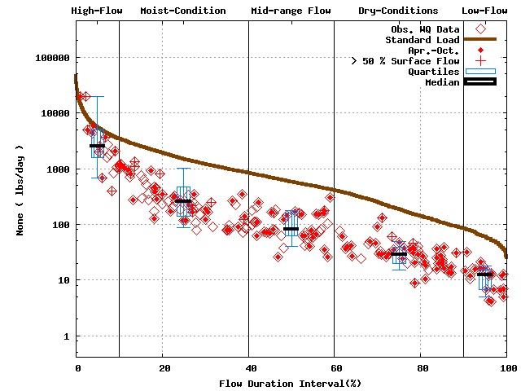 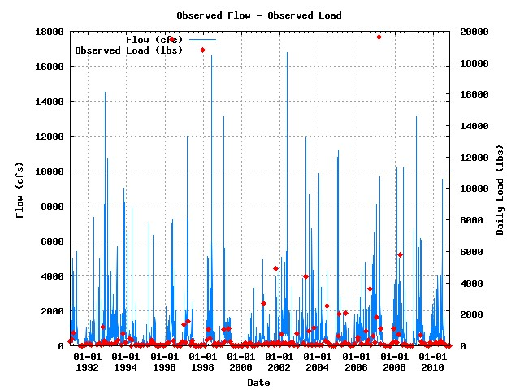

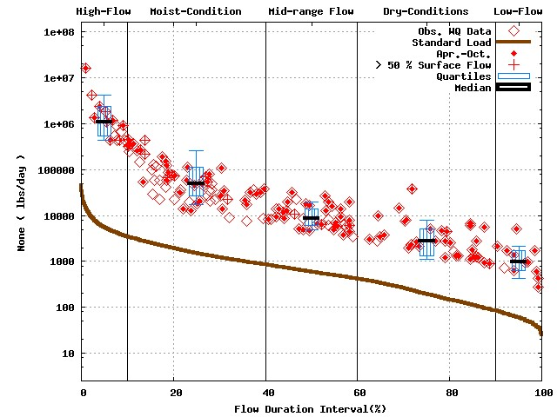 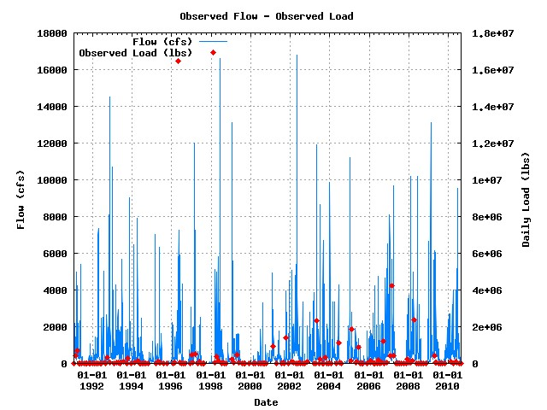

Numbers of water quality sample for Baseflow dominant flow cases 118/105/87

**USGS 03339500 / WSU050-0005 (Baseflow dominant flow’s plot) [1991 to 2010]**



**USGS 03351500 / WWU090-0002 (N, P, and TSS) [1991 to 2010]**

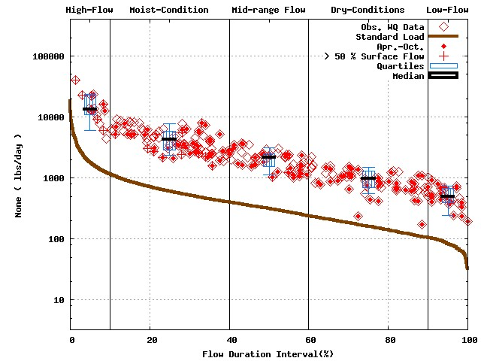 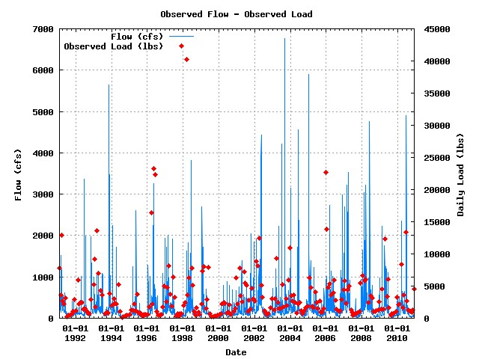

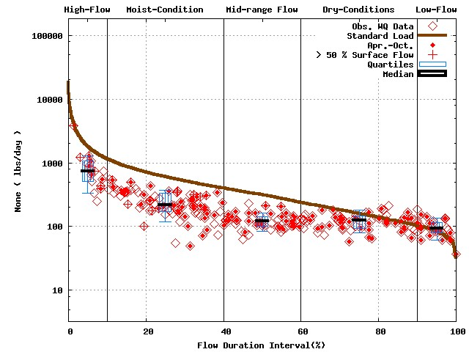 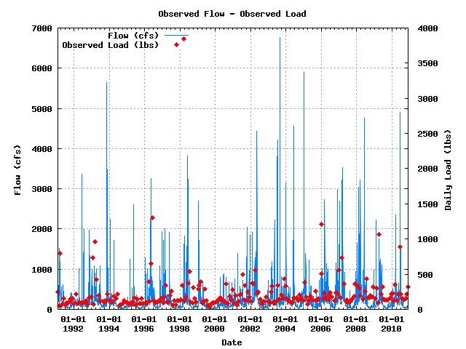

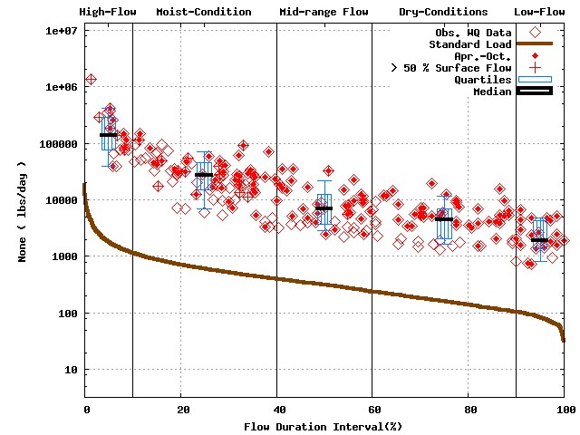 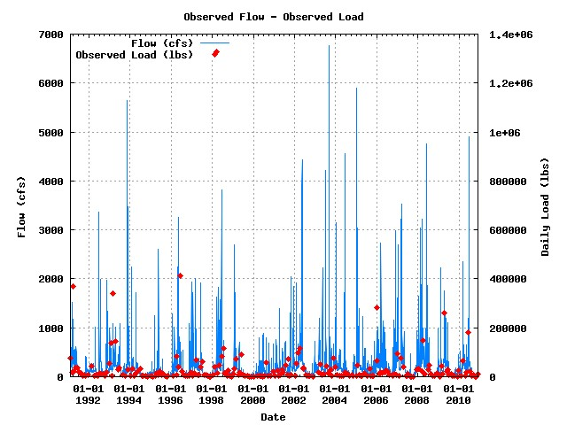

Numbers of water quality sample for Baseflow dominant flow cases 123/123/113

**USGS 03351500 / WWU090-0002 (Baseflow dominant flow’s plot) [1991 to 2010]**



**USGS 03353500 / WWU120-0002 (N, P, and TSS) [1991 to 2010]**

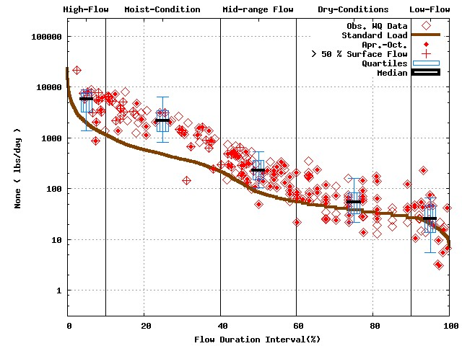 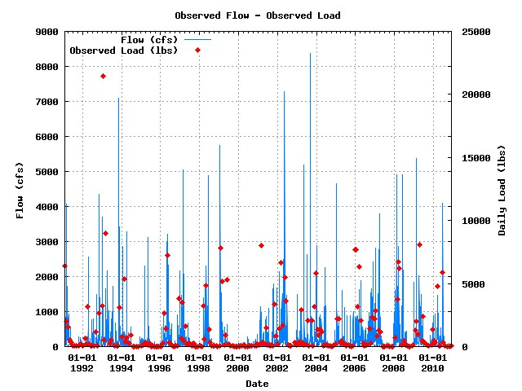

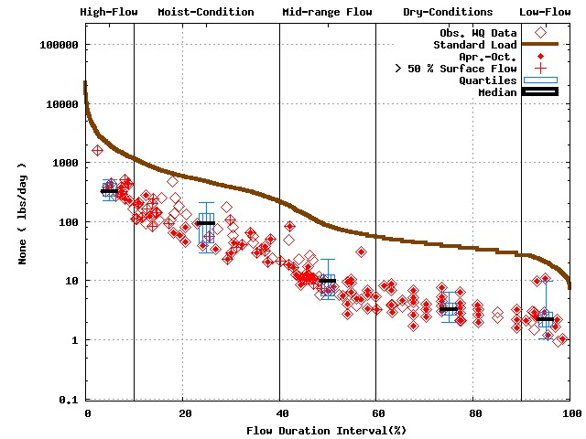 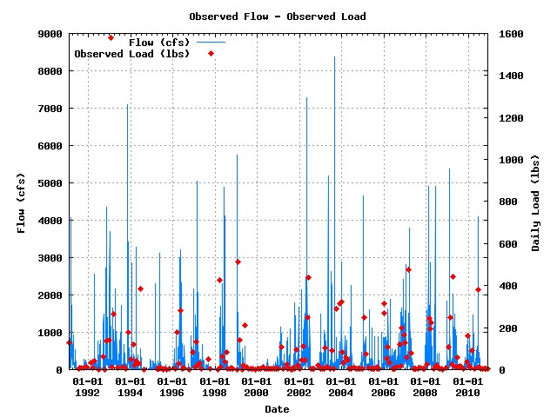

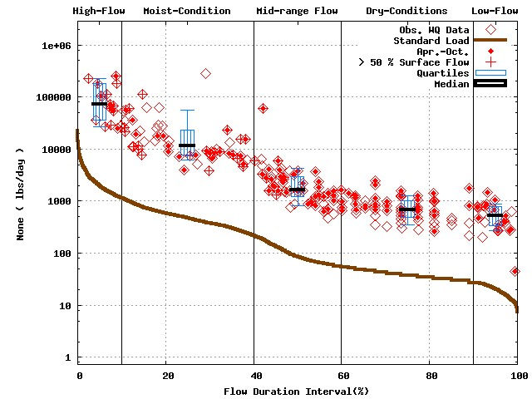 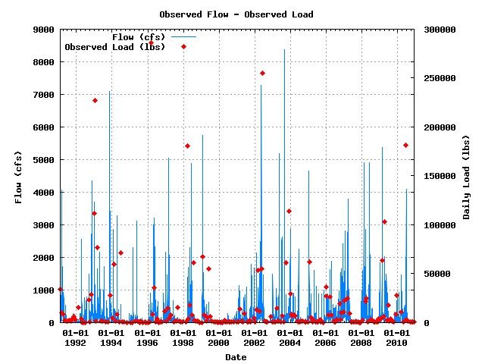

Numbers of water quality sample for Baseflow dominant flow cases 106/85/98

**USGS 03353500 / WWU120-0002 (Baseflow dominant flow’s plot) [1991 to 2010]**



**USGS 03358000 / WWE060-0002 (N, P, and TSS) [1991 to 2010]**

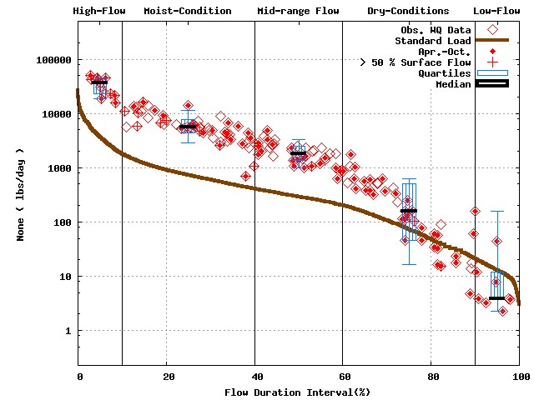 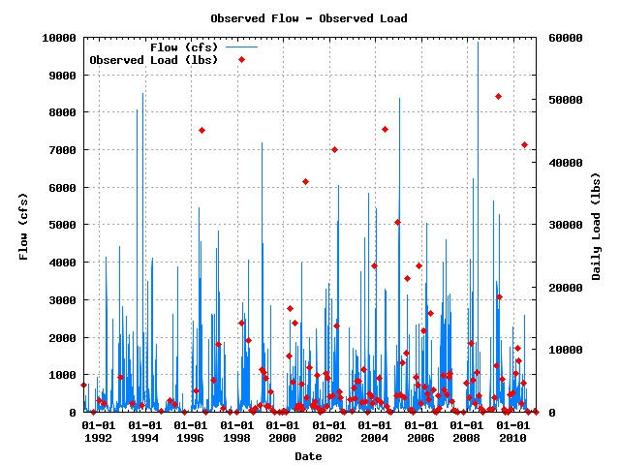

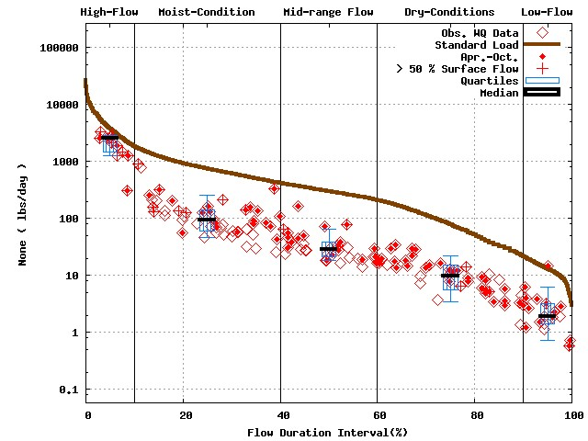 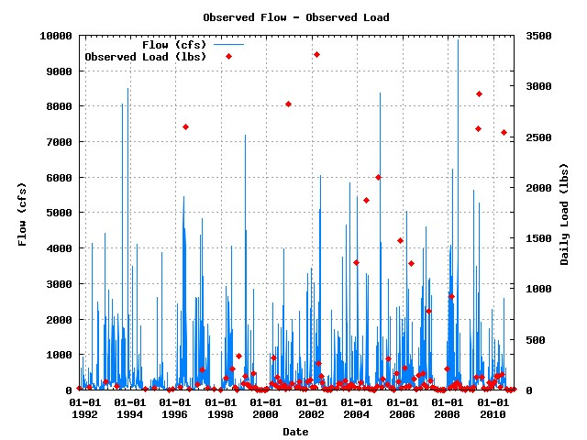

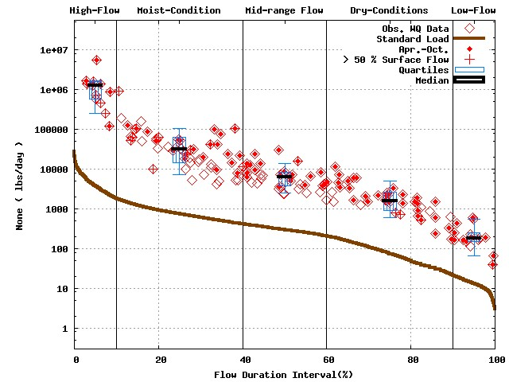 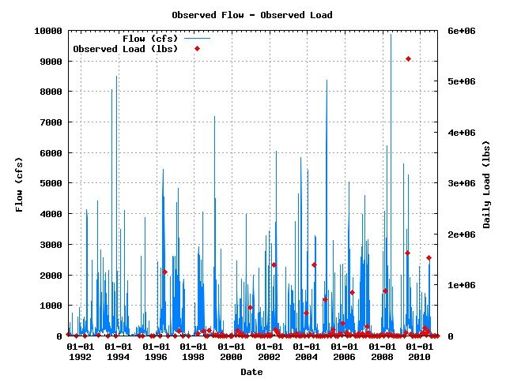

Numbers of water quality sample for Baseflow dominant flow cases 96/94/94

**USGS 03358000 / WWE060-0002 (Baseflow dominant flow’s plot) [1991 to 2010]**



**USGS 04094000 / LMG020-0005 (N, P, and TSS) [1991 to 2010]**

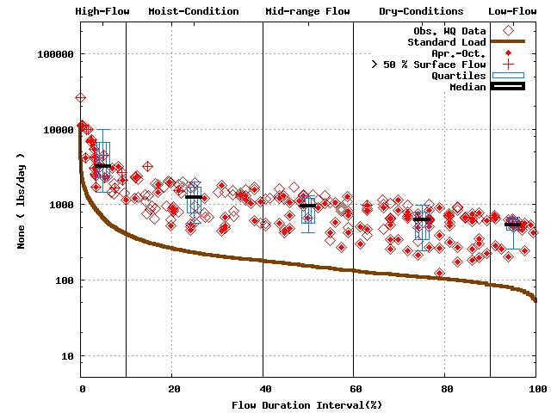 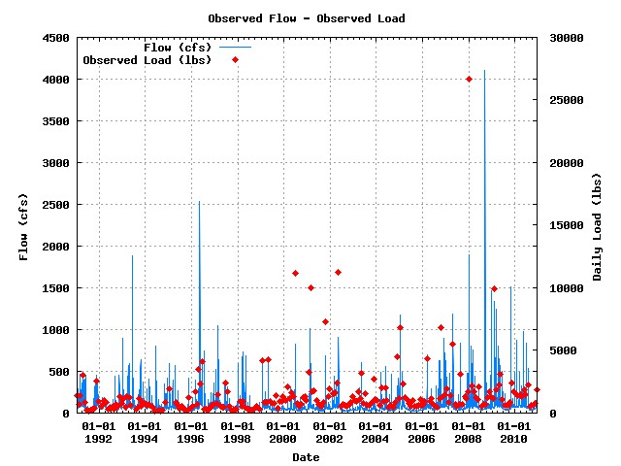

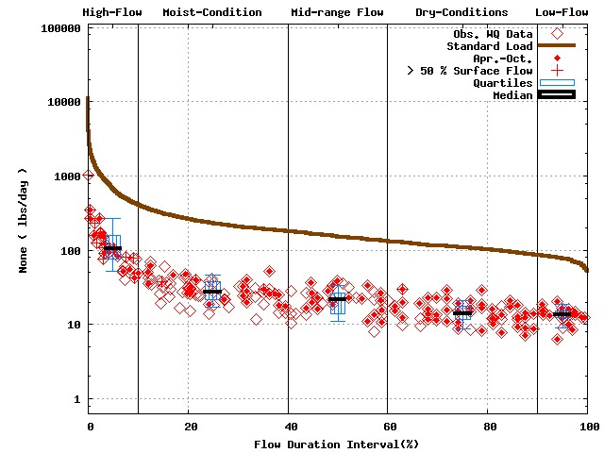 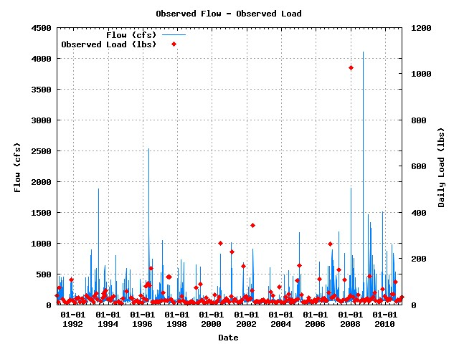

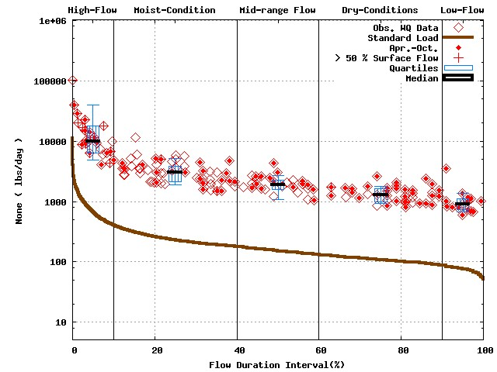 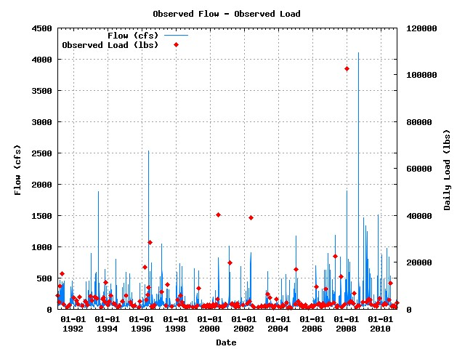

Numbers of water quality sample for Baseflow dominant flow cases 92/89/70

**USGS 04094000 / LMG020-0005 (Baseflow dominant flow’s plot) [1991 to 2010]**



**USGS 04183000 / LEM010-0014 (N, P, and TSS) [1991 to 2010]**

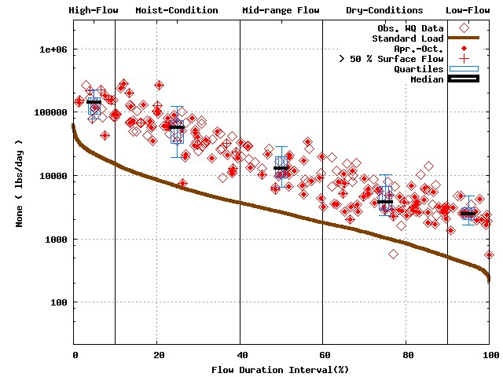 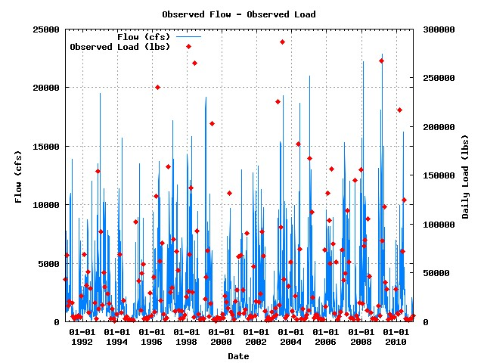

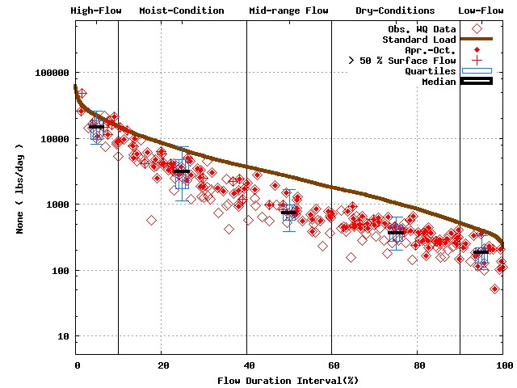 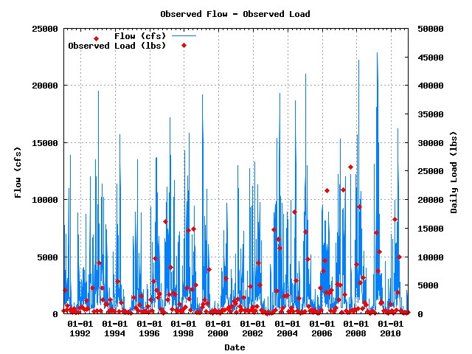

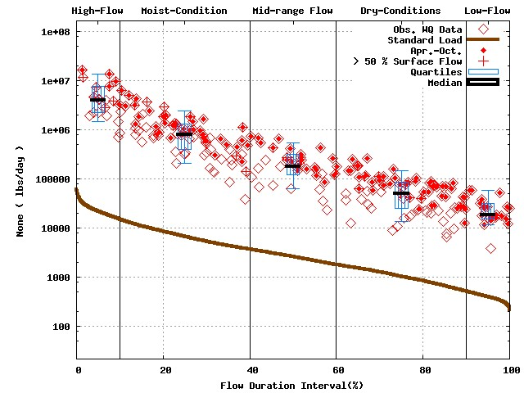 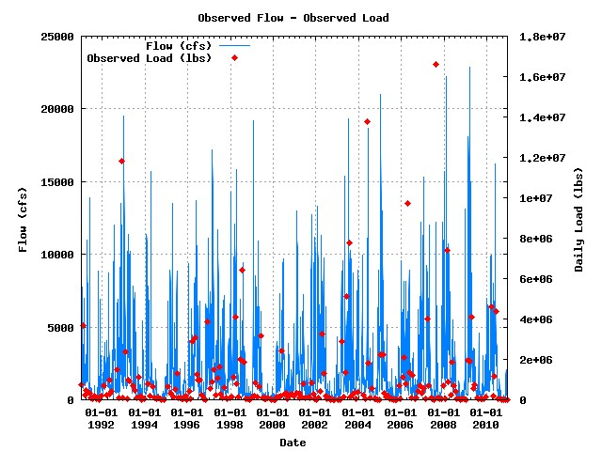

Numbers of water quality sample for Baseflow dominant flow cases 103/103/99

**USGS 04183000 / LEM010-0014 (Baseflow dominant flow’s plot) [1991 to 2010]**



**USGS 05536190 / UMC030-0004 (N, P, and TSS) [1991 to 2010]**

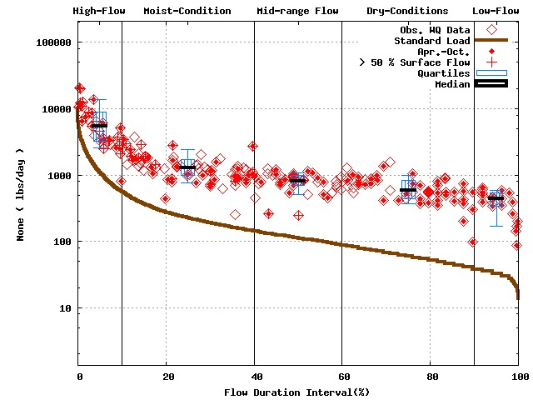 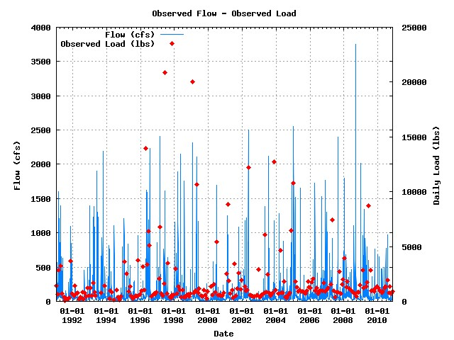

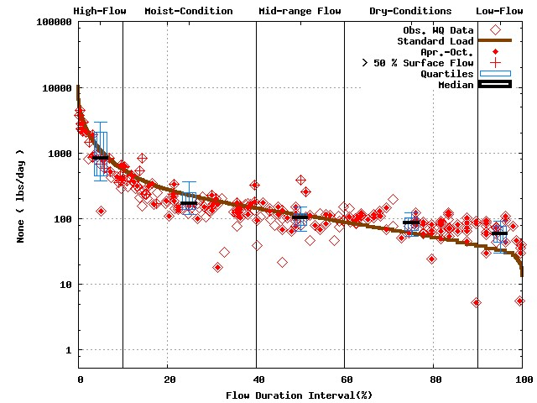 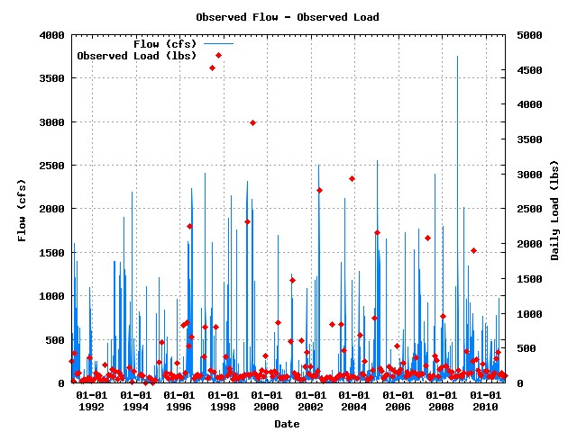

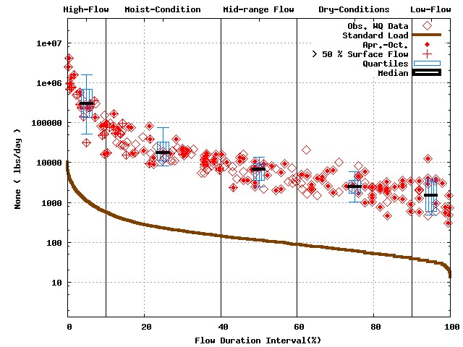 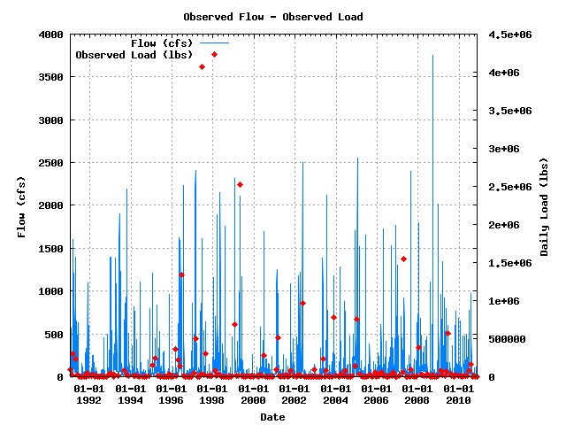

Numbers of water quality sample for Baseflow dominant flow cases 107/108/107

**USGS 05536190 / UMC030-0004 (Baseflow dominant flow’s plot) [1991 to 2010]**



